Homework 2 Student Name Narahari Rahul Malayanur

AuE 8930: Machine Perception and Intelligence

Instructor: Dr. Bing Li, Clemson University, Department of Automotive Engineering

* Refer to Syllabus for homework grading, submission and plagiarism policies;

* Submission to Canvas (Due: Tues. Feb. 9, 2021 11:59 pm), including:

* This document (with answers), and with your program results/visualization;
* A .zip file of source code (and data if any) with names indicating question number;

1. a) Visualize continuous period signal x(t) = 2 + 3 * cos (500  t) + 2 * cos (1000  t) + 3 * sin (2000  t) in time-domain (axis: Amplitude and t) (5 points)

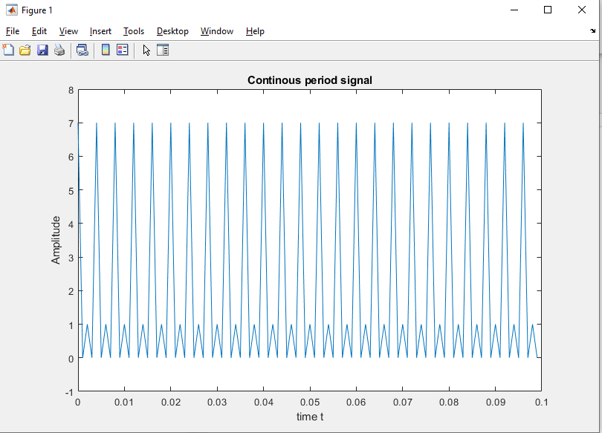

b) visualize its digital Fast Fourier transform (axis: Amplitude and f). Given Sampling frequency as 1K HZ. (5 points)

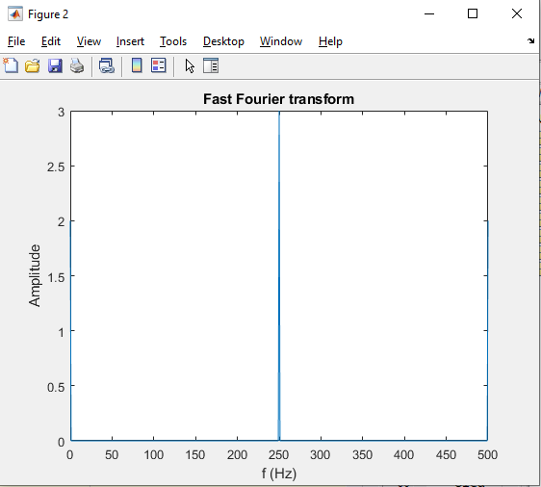

1. a) Visualize the discrete signal x(k) = 0 for k [0 499] & x(k) = 1 for k  [500 1000) s (sampling frequency as 1M HZ) in time-domain (Amplitude and t) (5 points);

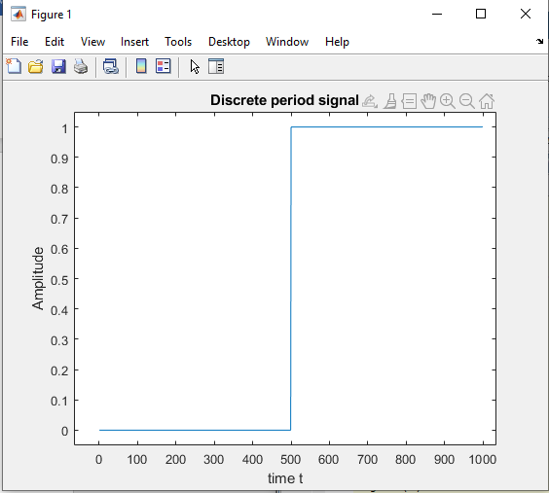

b) Visualize its digital Fast Fourier transform (Amplitude and f), find its -3dB

(called half-power) bandwidth frequencies (f_low, f_high) in frequency spectrum. (15 points)

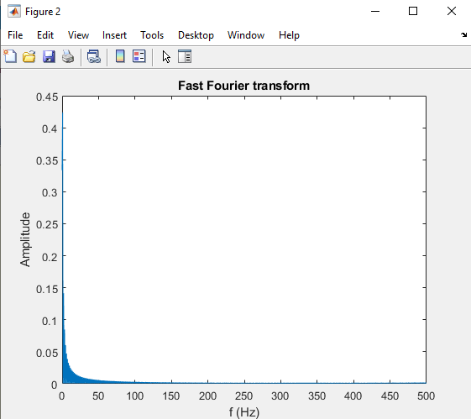

Half - power:

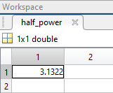

High and low frequency:

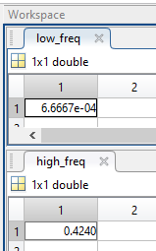

1. For discrete signal x(k) = 20 for k [0 499], add a normally distributed random noise n(k) (mean 0, variance 1) to the signal, and get x(k) = x(k) + n(k). Then, apply a normalized (mean 0, standard deviation 1) [Gaussian kernel](http://dev.theomader.com/gaussian-kernel-calculator/) (windows size 3 and 11 respectively as a low pass filter, then rescale all elements to make sure the sum is 1) to perform convolution y(k) = x(k)  h(k) (h presents the impulse response, and in this case it’s the filter) by using basic arithmetic operations only. (Implement the convolution without using library API)
2. Visualize both x(k) and x(k) in one figure (10 points)

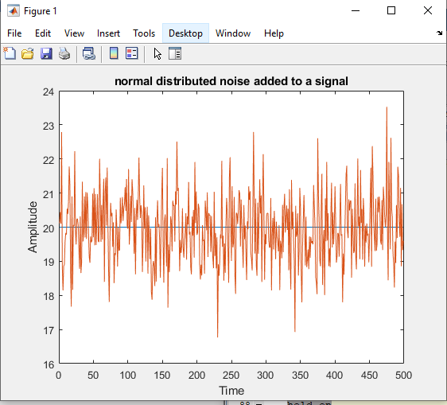

1. Visualize both x(k), and y(k) based on kernel window size 3 in one figure (15 points)

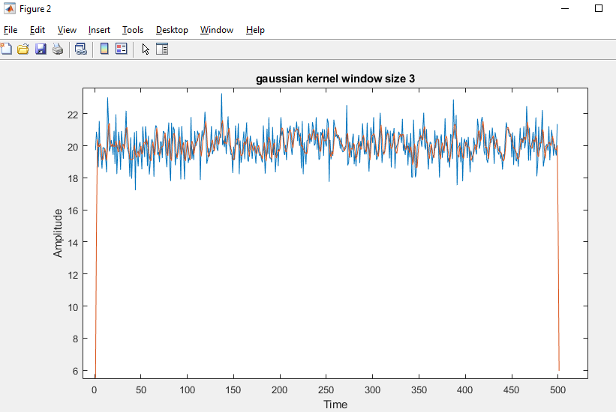

1. Visualize both x(k), and y(k) based on kernel window size 11 in one figure (5 points)

Tip: You may consider using zero-padded for edges during convolution operation

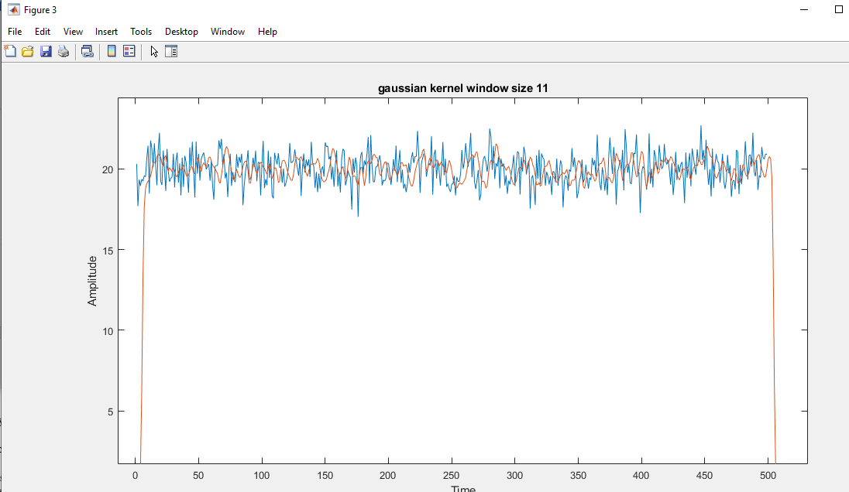

1. Write a 2~3 pages of survey on the sensing and measurement of a specific 1D physical quantity related to the automotive (vehicles, manufacturing, etc) such as: vibration, friction, temperature, speed, or distance. The grading of this question is based on the contents which the survey covers (40 points):

In this survey we shall discuss about importance of sensing and measuring the vehicle tire friction.

**The importance of measuring this physical quantity** (5 points);

Friction is very important attribute required for a car’s tire to drive safely. It is the force that enables the car to move forward at all. It is the friction force that keeps the tires from sliding on the road. It is also important that car maintains a good amount of friction while it is taking a turn so that it does not drift away from its path. In snowy conditions the amount of friction between the surface and the car’s tire will be very less and it becomes really difficult to break or sudden accelerate the vehicle during those conditions.

**The challenges of measuring this physical quantity (5);**

Measuring the friction between the road surface and the wheels is always a challenge. It is a really important factor to measure because a lot driver assist algorithms such as Vehicle stability control, the ABS depend on the friction between the two surfaces.

1. Tire-road noise, pavement noise, tire road interaction noise.
2. It depends on the condition of the tire and the condition of the road surface.
3. lack of data that provides significant discrimination between different friction coefficients.
4. It depends on the vehicle speed it both longitudinal and lateral directions.

Hence the challenge is to measure all these data from various sensors on the run and then develop an approach which would measure the surface.

**Existing approaches of measuring this physical quantity (15)**

It is very important to measure friction between the tire and road surface and there have been various approaches to solve this challenge at various road conditions.

1. vision-based methods that can view the road in front of the vehicle and produce an estimate, such as Holzmann (2006), Sato (2007) and Yamada (2005).
2. Finally, the lateral and yaw dynamics of the vehicle have been investigated as a mechanism for producing the estimate through nor-mal driving excitation
3. Independent Wheel Effects in Real Time Estimation of Tire-Road Friction Coefficient from Steering Torque.
   1. Approach:
      1. The use of steering torque to identify the surface friction coefficient is one possible way to perform estimations in real time using only normal driving dynamics of the vehicle for estimation. [1]
   2. Problems:
      1. Large variability in the steering torque measurements, the interactions of weight transfer, the distributions of force in the contact patch are the major problems while estimating the dynamics of the steering torque estimation.
      2. Lack of separate sensors for the left and right forces, causes estimation algorithms to utilize the lumped measurements of the front axle steering moment.
4. Dynamic Friction Models for Road/Tire Longitudinal Interaction.
   1. Approach:
      1. A novel dynamic friction force model for the longitudinal road/tire interaction for wheeled ground vehicles.
      2. It is based on a dynamic friction model developed previously for contact-point friction problems. It assumes a contact patch between the tire and the ground a partial differential equation for the distribution of the friction force along the patch.
      3. An ordinary differential equation (the lumped model) for the friction force is developed, based on the patch boundary conditions and the normal force distribution along the contact patch.
   2. Problems:
      1. The frictional force is only addressed for longitudinal force in this approach.
5. Slip-based tire-road friction estimation.
   1. Approach:
      1. It uses the wheel slip: the difference between the wheel velocities fo the driven and non-driven wheels.
      2. It uses the Kalman filter to estimate the slip slope at all the times.
   2. Problems:
      1. Relative information is needed to the tire type and the condition.

**References:**

1) [1] - Independent Wheel Effects in Real Time Estimation of Tire-Road Friction Coefficient from Steering Torque.

2) [2] - Dynamic Friction Models for Road/Tire Longitudinal Interaction.

3) [3] - Slip-based Tire-Road Friction Estimation.